**Practical App Development Exercise**

***Please submit your exercise results by 9th August 23:59:59 London time.***

This is a short exercise to test your app development skills. In this exercise, you are supposed to build a mobile application. The goal of this exercise is not to test your ability to build beautiful mobile applications. So, don’t worry if the UI doesn’t look visually appealing - this is not what we are testing. We are just assessing how you approach the problem and your ability to build robust and scalable applications.

**Tasks**

**You need to complete at least one task to qualify for the next stage of the application.**

*However,*

* *If you complete Task 1, you progress to the next stage of the application*
* *If you complete Task 1 and 2, you progress to the 3rd stage of the application*
* *If you finish all the tasks, you directly qualify for the final interview*

**Task 1**

Build a mobile application that shows a risk heatmap.

The application reads latitude and longitude from file [Coordinates.csv](https://drive.google.com/file/d/1mh6i7Mwr9TwgsspMOXzdvxSDNErbvMKV/view?usp=sharing) (Feel free to pick as many coordinates as you like) and plots it on a UK map. Every coordinate is represented by a colour on the UK map.

Write a script that changes the colour of each coordinate **every second**. Use the traffic light colours to show variation of risk. So, the mobile application never shows the UK map with the same risk heatmap colours for any given point in time.

Please look at the hourly change in colours in the images below. Please note the images are only for reference and candidates are not expected to replicate it for the mobile application( however, you may choose to do so).

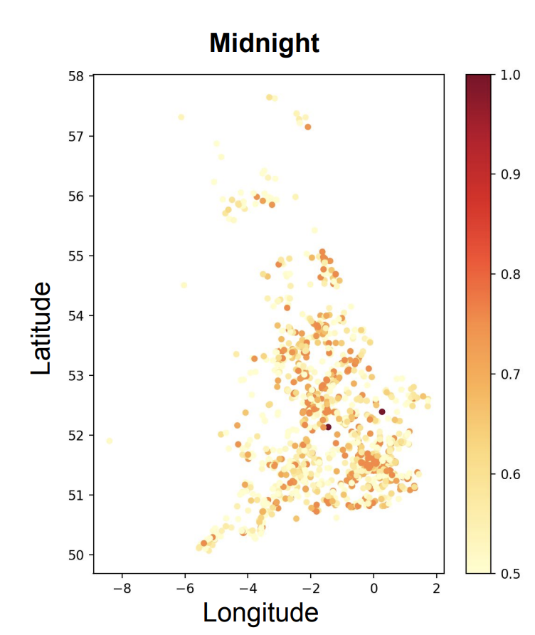 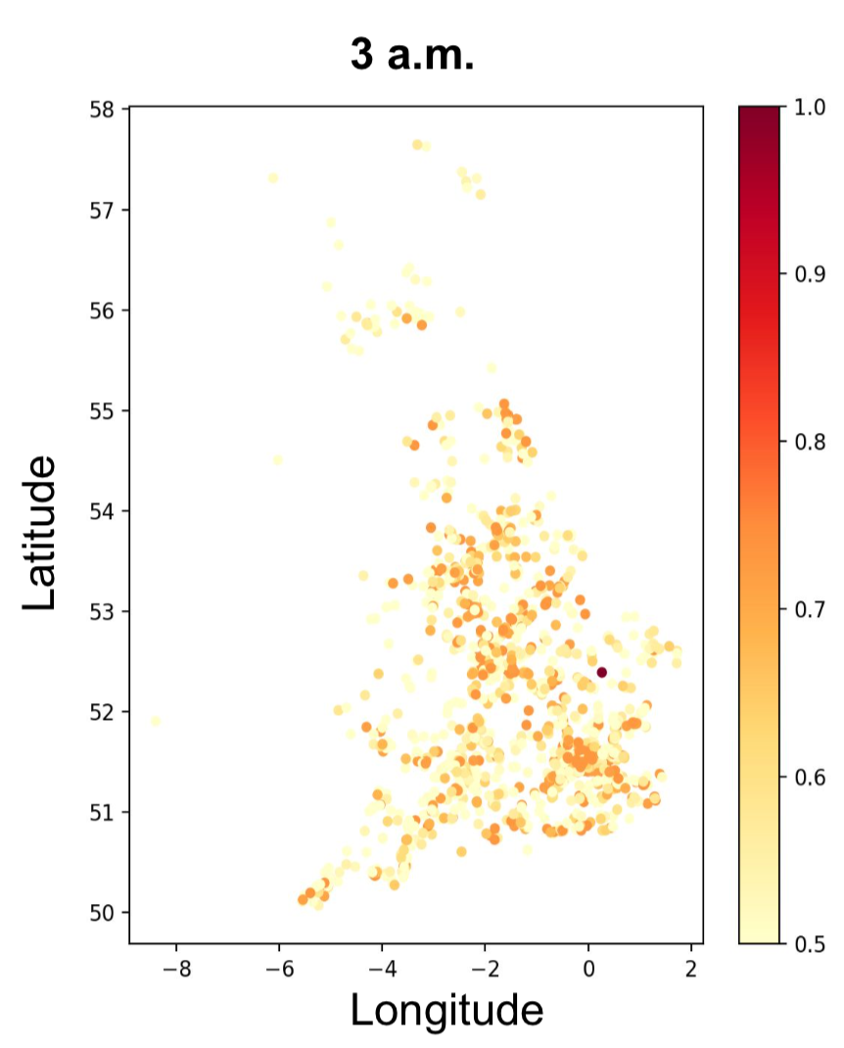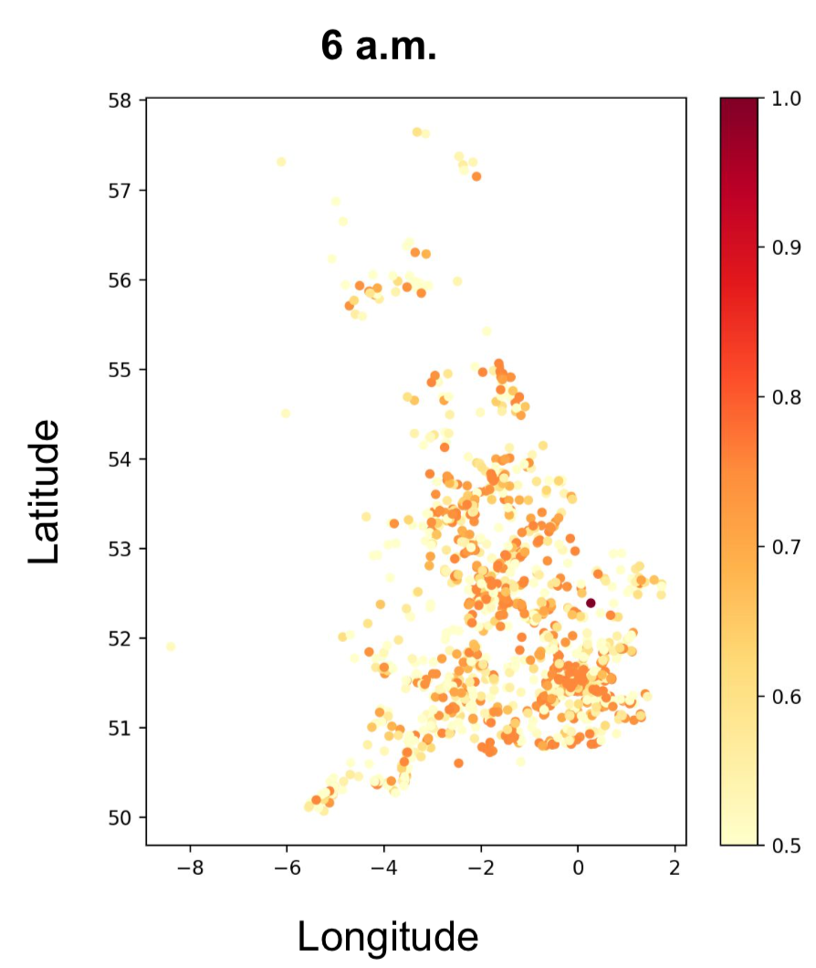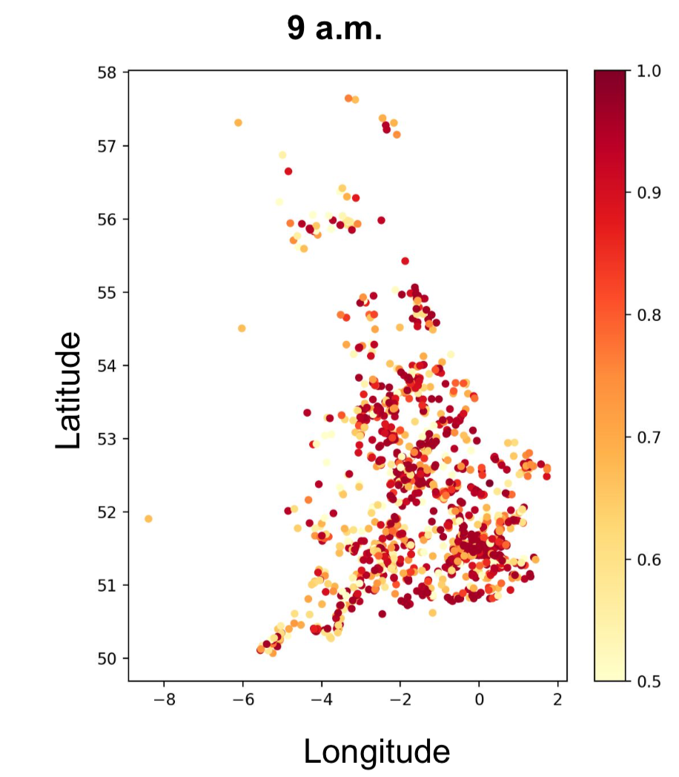

(Hint: For example: If you pick 5 coordinates from Coordinates.csv file-

55.125539,-3.365183

55.092093000000006,-3.321624

55.210584999999995,-3.128341

55.009829,-3.17122

55.239245,-3.410739

The script generates a random number between 1-10 for each of these coordinates **at 09:13:02**, i.e.

55.125539,-3.365183 **6**

55.092093000000006,-3.321624 **8**

55.210584999999995,-3.128341 **1**

55.009829,-3.17122 **4**

55.239245,-3.410739 **7**

So, on the frontend, it will display orange for (55.125539,-3.365183) and (55.239245,-3.410739), red for (55.092093000000006,-3.321624), yellow for (55.009829,-3.17122) and green for (55.210584999999995,-3.128341)

The script runs again and generates new random numbers between 1-10 for each of these coordinates **at 09:13:03, i.e.**

55.125539,-3.365183 **1**

55.092093000000006,-3.321624 **2**

55.210584999999995,-3.128341 **3**

55.009829,-3.17122 **4**

55.239245,-3.410739 **7**

So, on the frontend, it will display orange for (55.239245,-3.410739), yellow for (55.009829,-3.17122) and green for (55.125539,-3.365183), (55.092093000000006,-3.321624) and (55.210584999999995,-3.128341)

The script runs again and generates new random numbers between 1-10 for each of these coordinates **at 09:13:04, i.e.**

55.125539,-3.365183 **9**

55.092093000000006,-3.321624 **8**

55.210584999999995,-3.128341 **1**

55.009829,-3.17122 **4**

55.239245,-3.410739 **7**

So, on the frontend, it will display orange for (55.239245,-3.410739 ), red for (55.092093000000006,-3.321624) and (55.125539,-3.365183), yellow for (55.009829,-3.17122) and green for (55.210584999999995,-3.128341)

Hope that helps!)

**Task 2:**

Build a mobile application that shows the real time location of vehicles on a UK map. The real time locations of vehicles can be found in file [realtimelocation.csv](https://drive.google.com/file/d/1BodkAoEf_R7pyaiU-LgEF4reZdvg4UKv/view?usp=sharing). The location changes every minute, so by just viewing the mobile application we can see different vehicles moving as their location changes. You are free to pick either all vehicles or only a handful to display on the UI.

**Task 3:**

Build a mobile application that shows both a risk heatmap **(**as described in **Task 1)** and the real time vehicle location on a UK map (as described in **Task 2**)

Please have a look at the image below for reference.

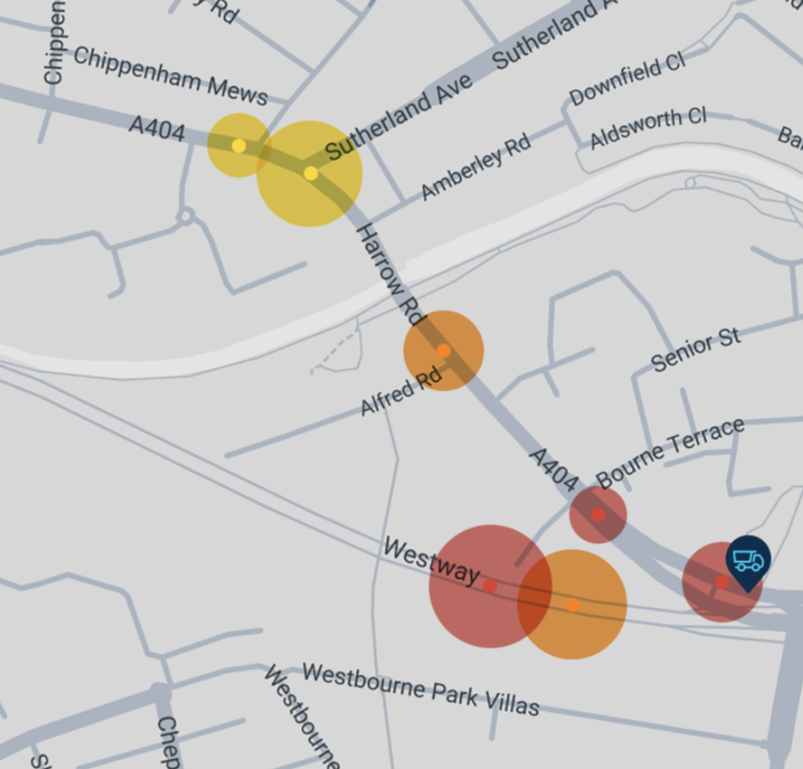

If you have questions regarding the tasks or require any further clarifications, please email us at [joinus@predina.com](mailto:joinus@predina.com) and we shall get back to you ASAP.

**Relevant docs**

[Coordinates.csv](https://drive.google.com/file/d/1mh6i7Mwr9TwgsspMOXzdvxSDNErbvMKV/view?usp=sharing)

[realtimelocation.csv](https://drive.google.com/file/d/1BodkAoEf_R7pyaiU-LgEF4reZdvg4UKv/view?usp=sharing)

**Deadline**

The exercise should be completed and the mobile application link and source code sent to us at [joinus@predina.com](mailto:joinus@predina.com) with subject **“Exercise-Results(Mobile-2)”. Please mention which tasks you have completed in the email.**

***Please submit your exercise results by 9th August 23:59:59 London time.***

**Note: PLEASE NOTE THAT APPLICATION WILL ONLY BE REVIEWED AFTER THE SUCCESSFUL SUBMISSION OF THE PRACTICAL EXERCISE.**